|  |  |
| --- | --- |
| Name | : Fance Satria Nusantara |
| Class | : PPTI 21 |
| NIM | : 2802538611 |

* **Figma elements:**

These elements created in canva using canva graphic element   
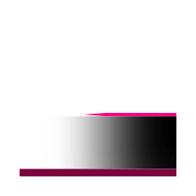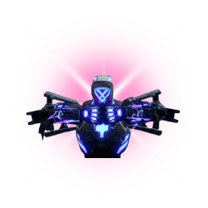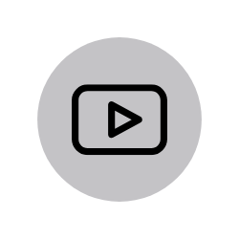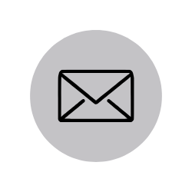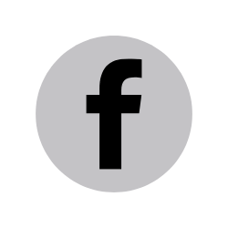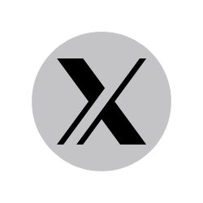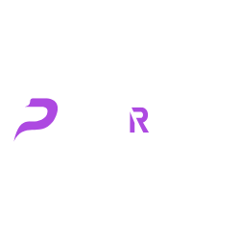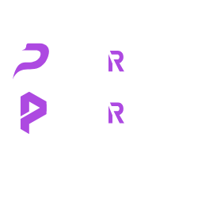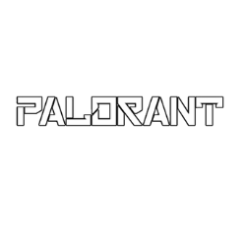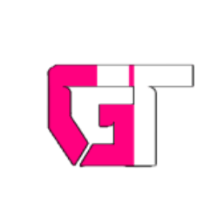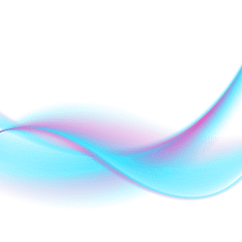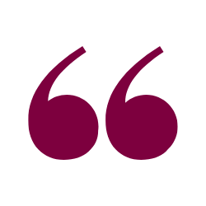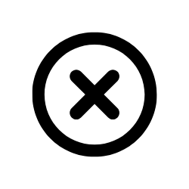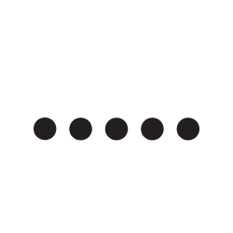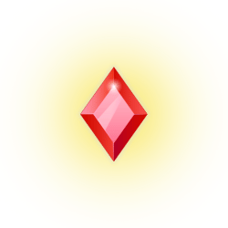

* **Banner Figma:**

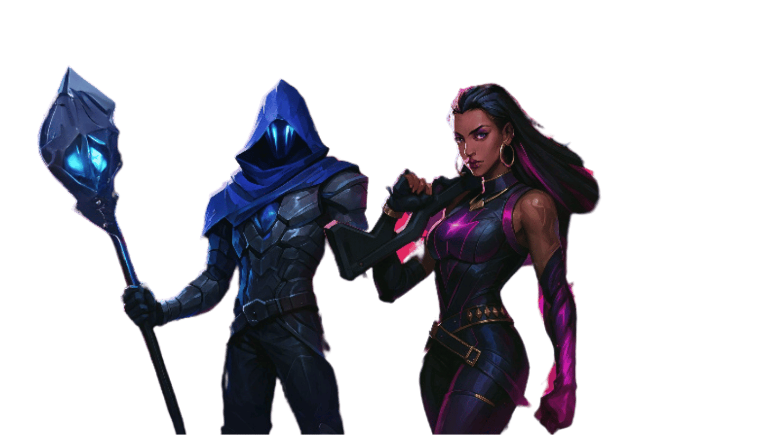

Figure for figma banner is generated from open ai

But the figure’s references for ai generate is from:

<https://images.app.goo.gl/A4EadbvHYQaieudv8>

<https://images.app.goo.gl/euWhCK5sZvXP6JZH9>

* **Top agent figma:**

Images for top agent section is get from internet, and then I expanded it in canva using canva ai  
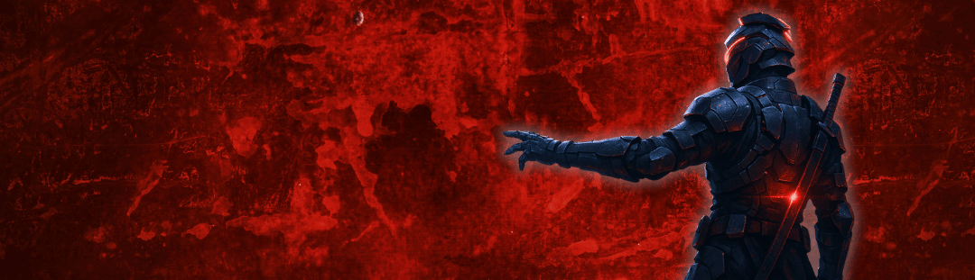

Exp: this image background from canva and the character is generated in open ai (dall-e) based from orion character(orion references is below in the agent section)

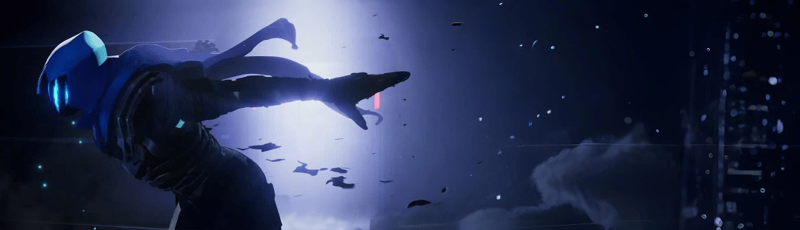

Src: <https://images.app.goo.gl/JEaaQ8BA2H9LLyv7A>

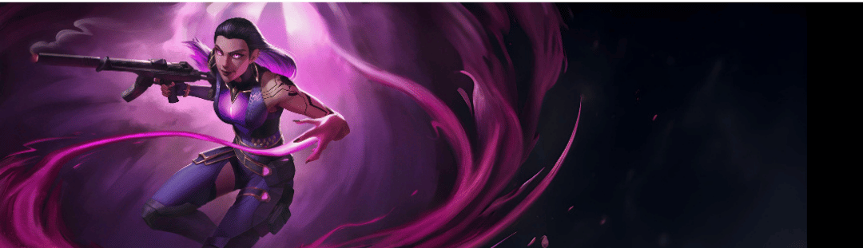

Src: <https://images.app.goo.gl/SfLzeLFckfj961JSA>

* **Figma backgrounds:**

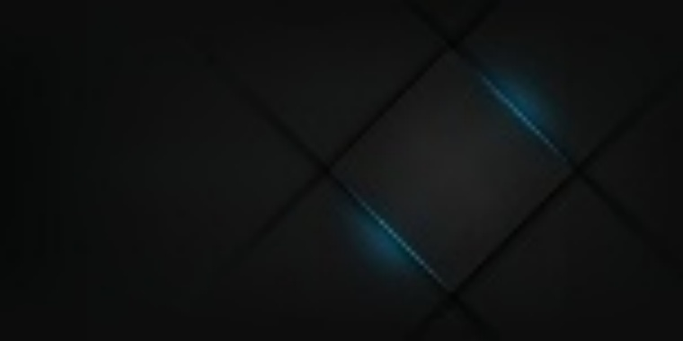

Get from internet, source: <https://images.app.goo.gl/Ekd3uWWUQasiDdHt8>

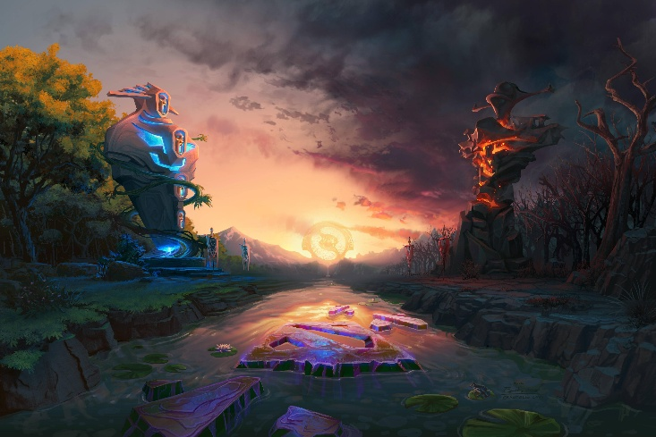

Get from internet, source: <https://images.app.goo.gl/GMfyWQGZoy9ULVvCA>

* **Website Agents:**  
  Agent card and agent detail ability created in canva using canva element and image from internet (reference below), for figma, I created in in figma but for website I re-created it using canva  
  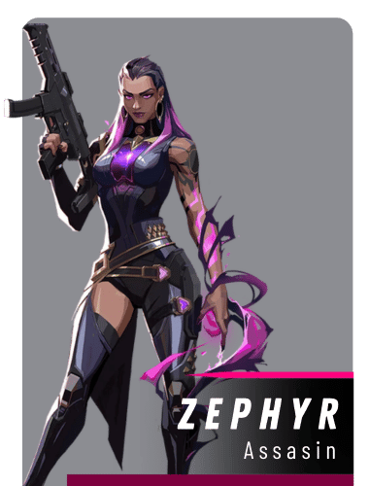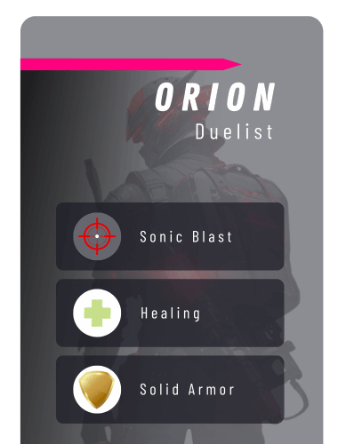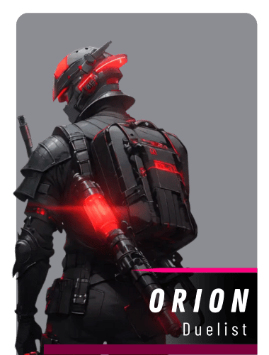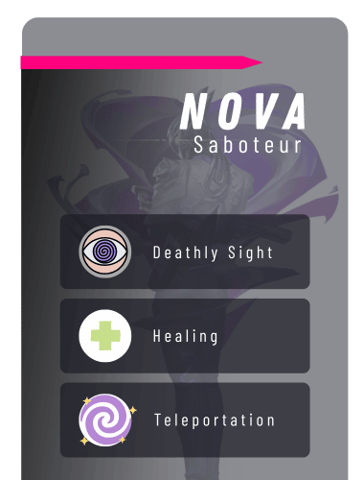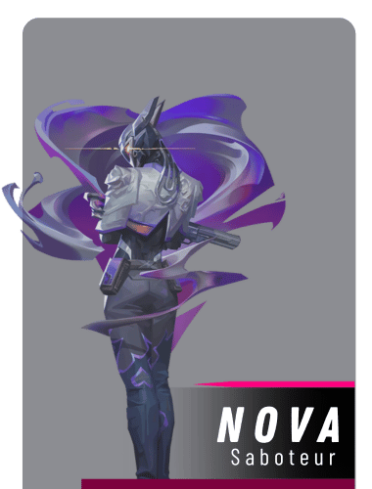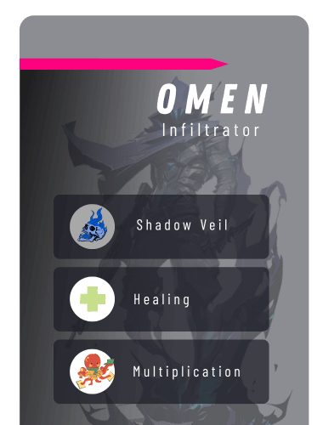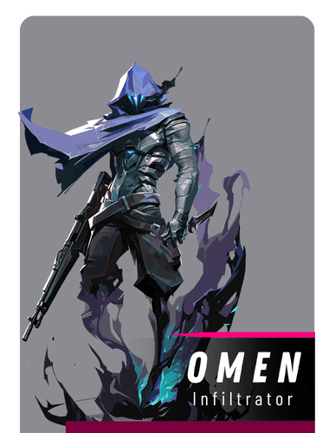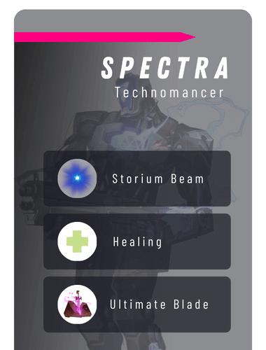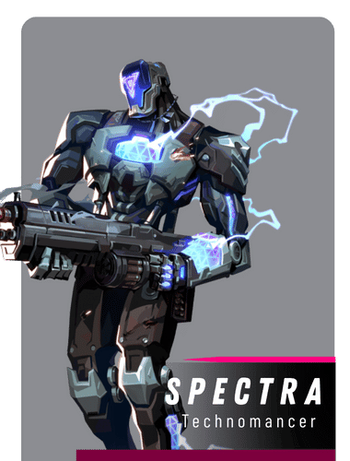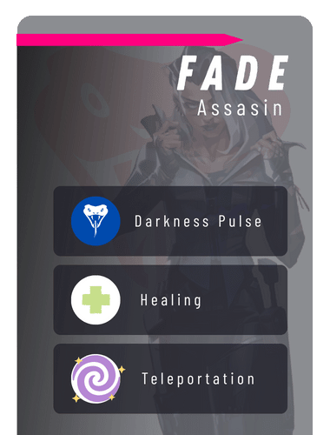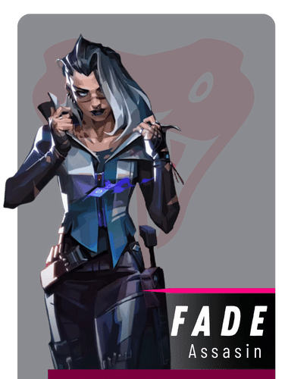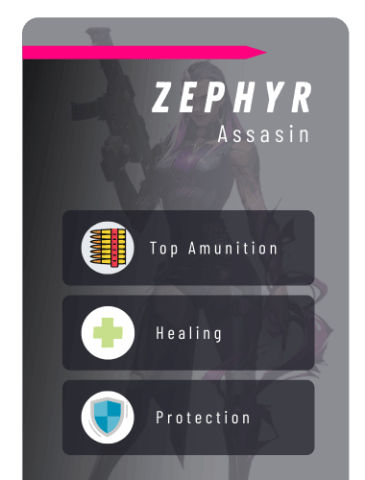
* **Maps:**

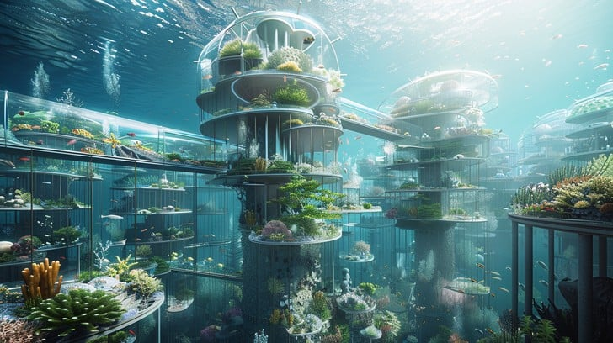

Get from internet, src: <https://images.app.goo.gl/erYMuERMEW5XAZ4Q9>

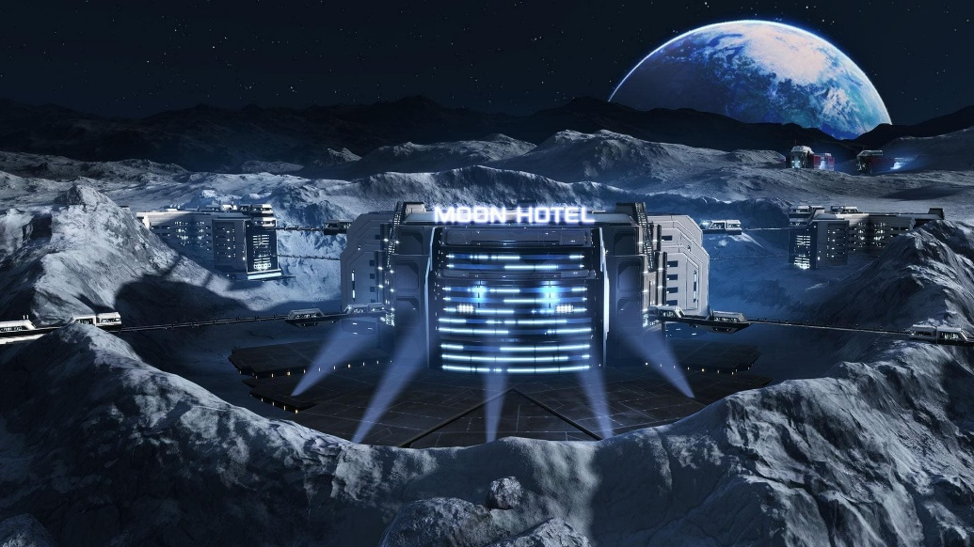

Get from internet, src: <https://images.app.goo.gl/bzhEFJwpQnTcvLZRA>

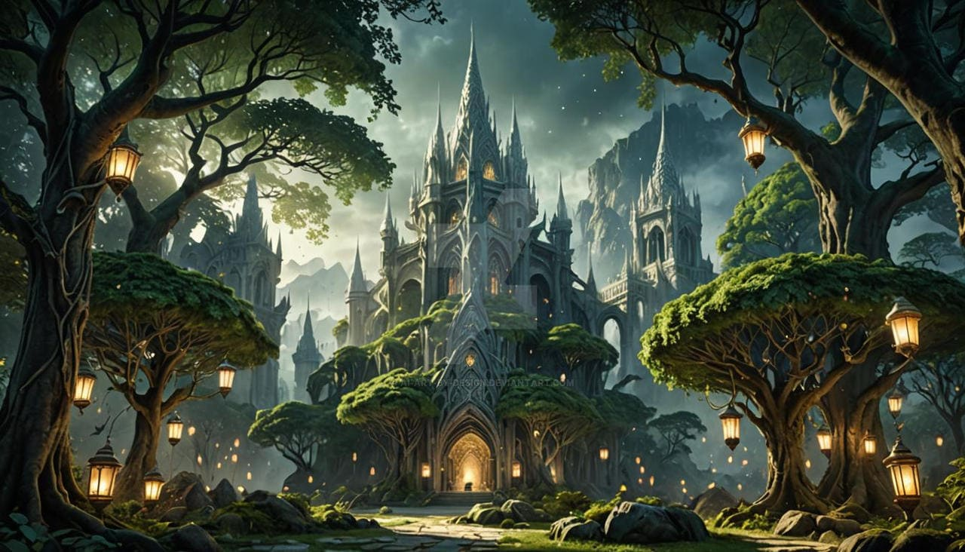

Get from internet, src: <https://images.app.goo.gl/1z6YNk8nopFVJVUv8>

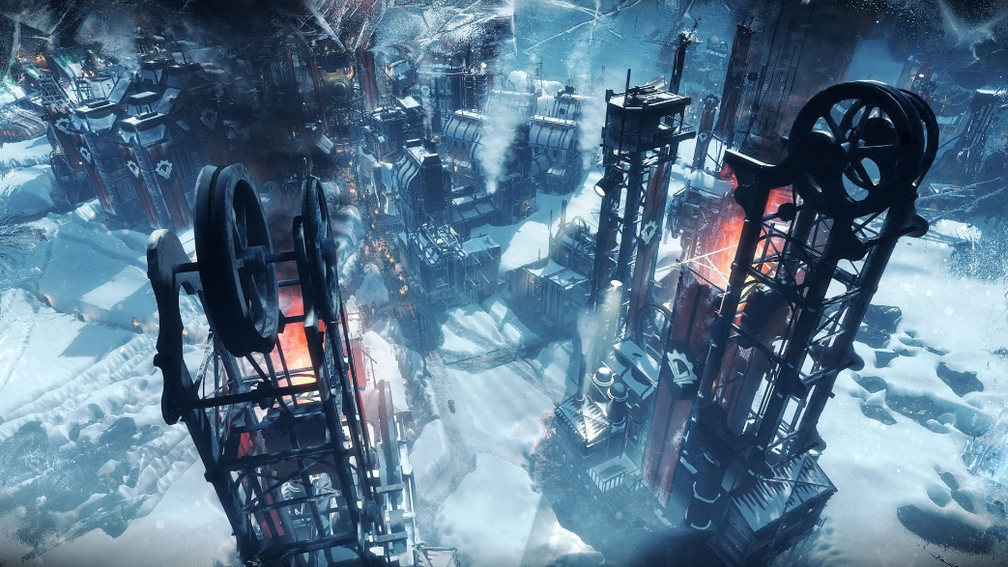

Get from internet, src: <https://images.app.goo.gl/zPv89EoSKJnfNpnS8>

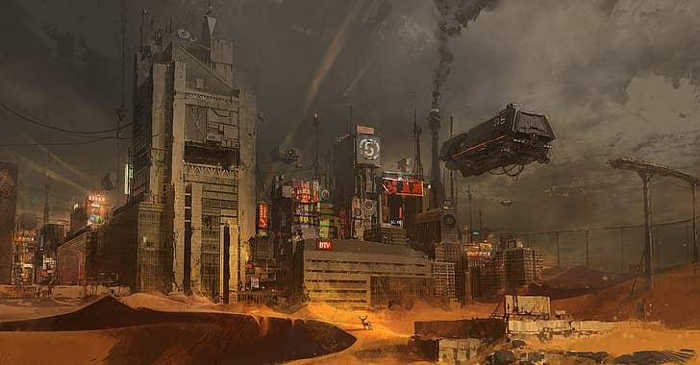

Get from internet, src: <https://images.app.goo.gl/Gpzd6pTPwmLCqyuM7>

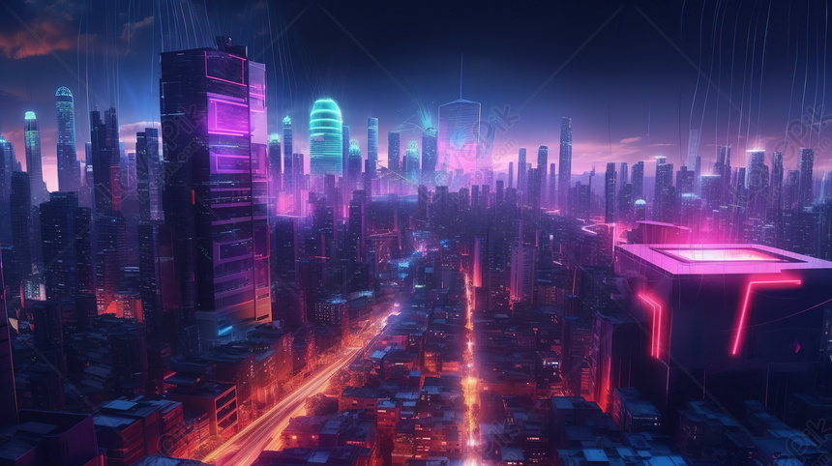

Get from internet, src: <https://images.app.goo.gl/EWm1Lbdrxm55tgbr9>

* **Agents:**

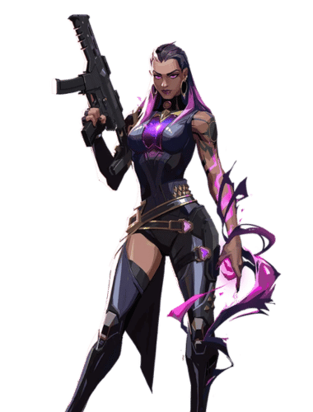

Get from internet, and then edited in canva for removing background, src: <https://images.app.goo.gl/XgcJMbt53kei2NAj8>

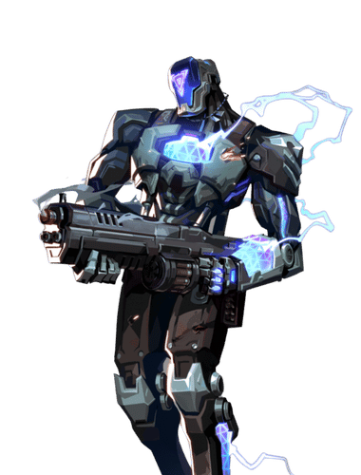

Get from internet, and then edited in canva for removing background, src: <https://images.app.goo.gl/ZtxoXRWpGCdoeoRe9>

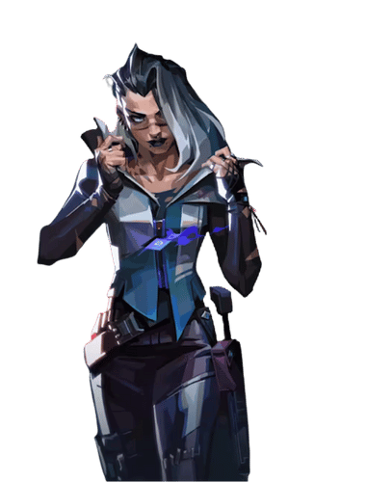

Get from internet, and then edited in canva for removing background, src: <https://images.app.goo.gl/u7yQTfNaf9BNibgs5>

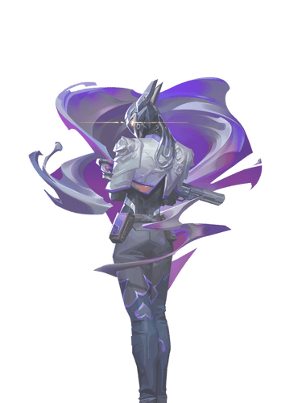

Get from internet, and then edited in canva for removing background, src: <https://images.app.goo.gl/fQRRiMBGhzz6xecc6>

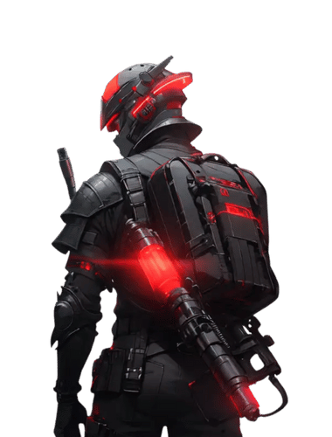

Get from internet, and then edited in canva for removing background, src: <https://images.app.goo.gl/w1VoxhfK24YpjrWp6>

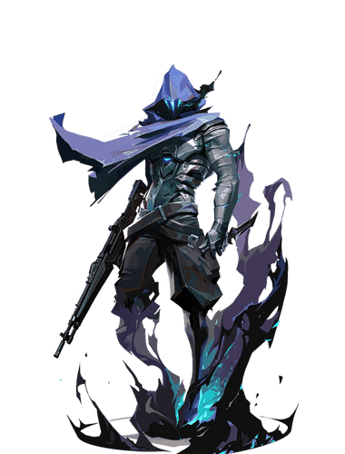

Get from internet, and then edited in canva for removing background, src: <https://images.app.goo.gl/1FR8TEmdVYByAg5v8>

* **News:**

For the news content (title, description)is generated from open ai

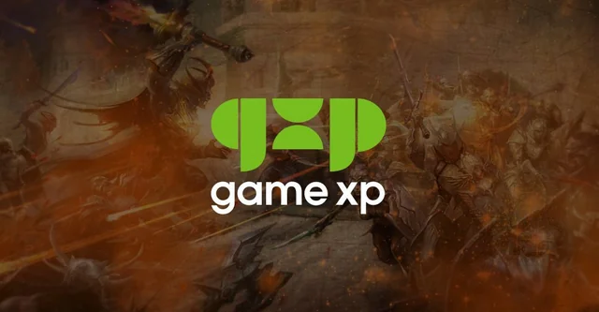

Src: <https://images.app.goo.gl/MHvEMFKtEdRh63Wx8>

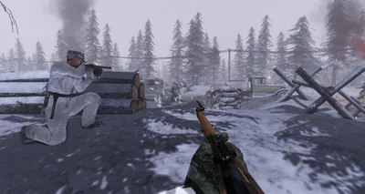

Src: <https://images.app.goo.gl/qFN6tGUMUwaC2ZgS8>

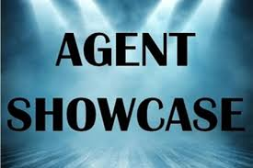

Src: <https://images.app.goo.gl/6q151sPei5N4BZWdA>

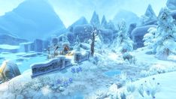

Src: <https://images.app.goo.gl/onm9FgaVDNnCfB1R6>

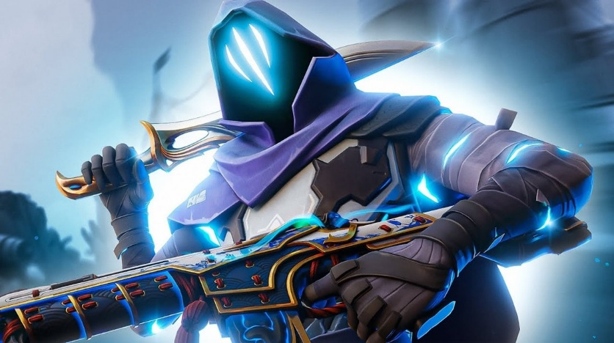

Src: <https://images.app.goo.gl/QJRMwXqwfZCiUKiv6>

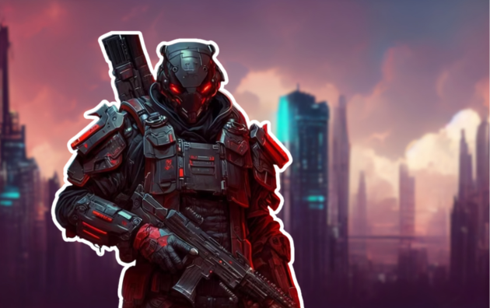

This image is created in canva, and the charcter or figure is get from <https://images.app.goo.gl/BeNmq9uMduVaWGfR6>

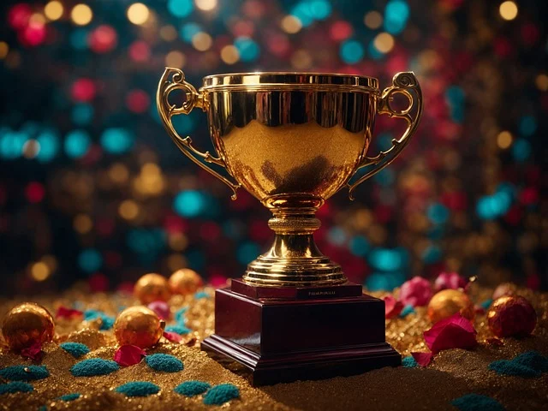

Src: <https://images.app.goo.gl/SbLwctFMtMjJJt1L6>

* **Website background:**

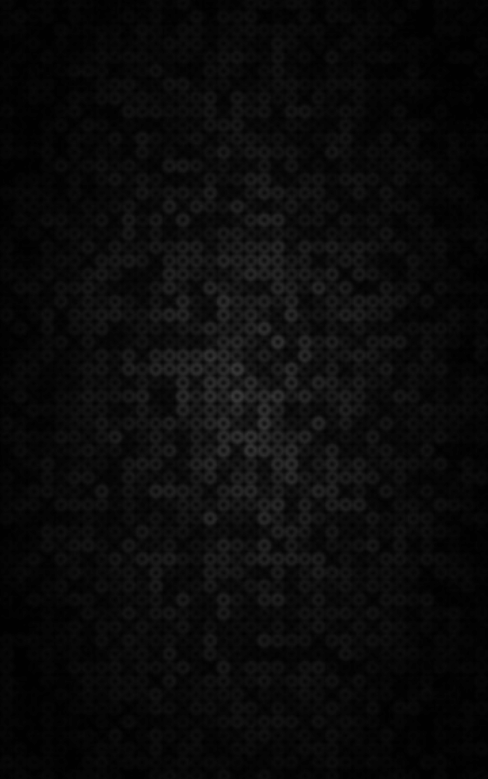

Src: <https://images.app.goo.gl/D2jvy2Xoc45DNwks6>

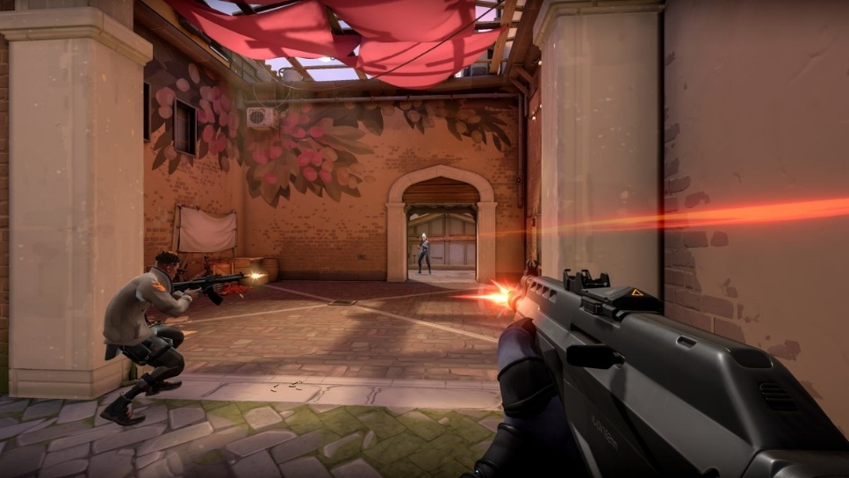

Src: <https://images.app.goo.gl/551eFt4TMTbPi2hY8>

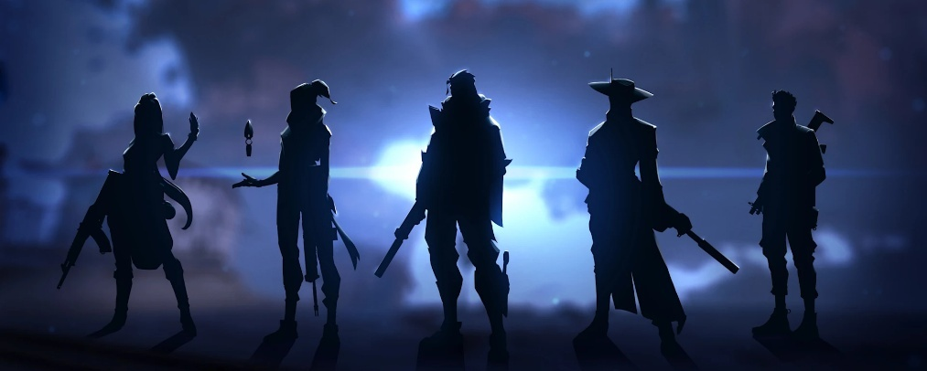

Src: <https://images.app.goo.gl/cyxERVEGaCFP113H6>



This dot pattern is created in canva using canva element

**Video for web jumbotron:**

  
src: <https://youtu.be/I3edFNWoHwc?si=y7s1ifZ0-XCVqOjQ>

**Fonts:**

* Game Battles font is downloaded from dafont, src: <https://www.dafont.com/game-battles.font>
* Overcame font is downloaded from 1001font, src: <https://www.1001fonts.com/overcame-demo-font.html>
* Groke Sport **(used in figma)** font is downloaded frm 1001font, src: <https://www.1001fonts.com/groke-sport-font.html>
* Omnitrinx **(used in figma)** font is downloaded from 1001font, src: <https://www.1001fonts.com/omnitrinx-font.html>